CS 461

Lab Assignment 10

Name: Gandhi Dhruv Vipulkumar

Institute ID: 202151053

Date: 16-11-2024

**Q. Working with AWS and Google Collab Architectures**

**NOTE:** No major changes done in provided ipynb file except updating the ARN role, the bucket name and installing s3fs thorough pip.

**Steps Followed:**

**1. Create a Domain in SageMaker**

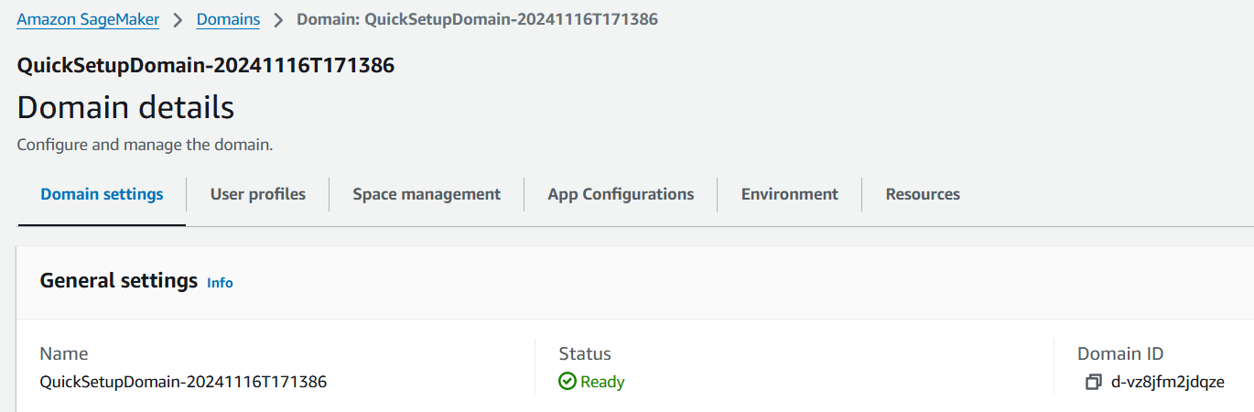

**2.** **Create an IAM User Role and give AmazonSageMakerFullAccess permission and attach AmazonS3FullAccess policy for data access**

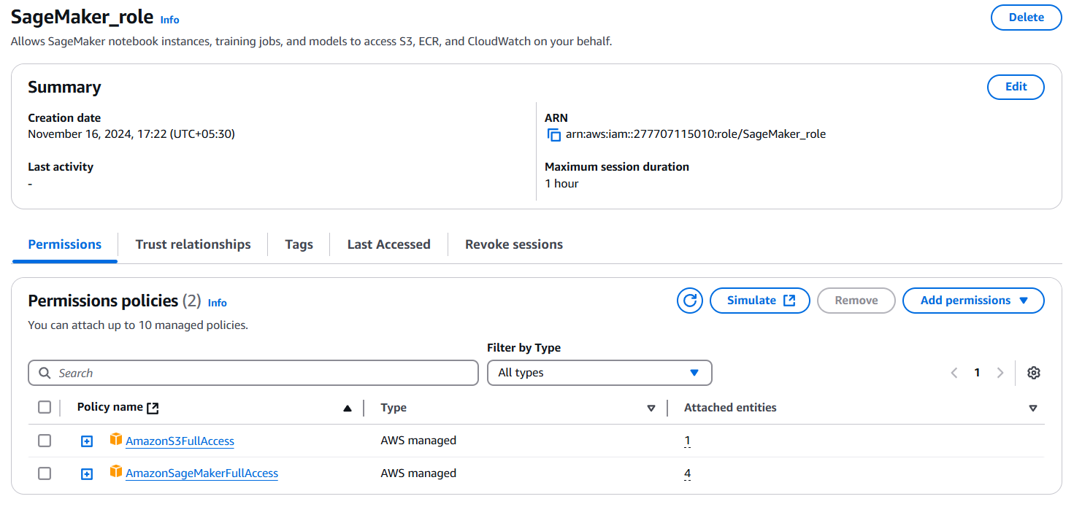

**3. Create an S3 Bucket and Upload the Dataset i.e. mob_price_classification_train.csv**

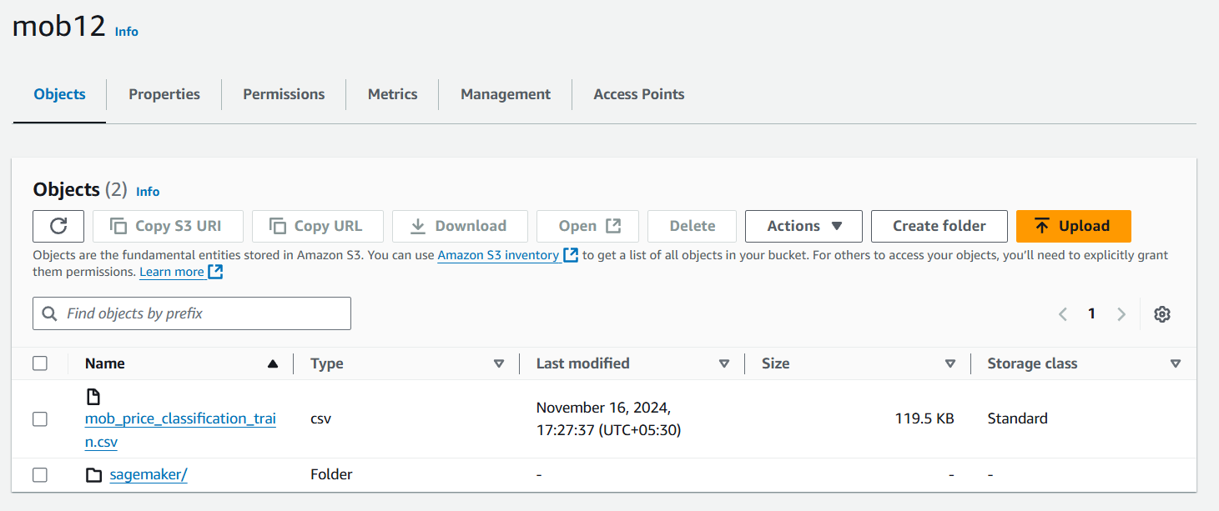

4. **Create a new user profile in the created domain of SageMaker console**:

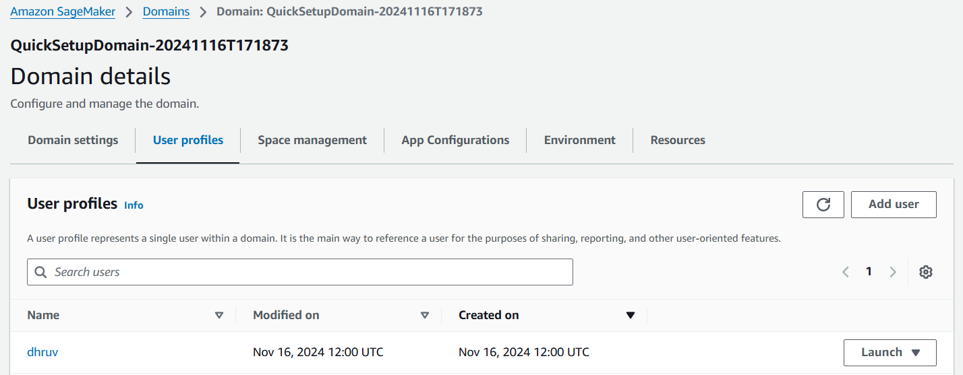

**5. Launch Studio from the SageMaker console.**

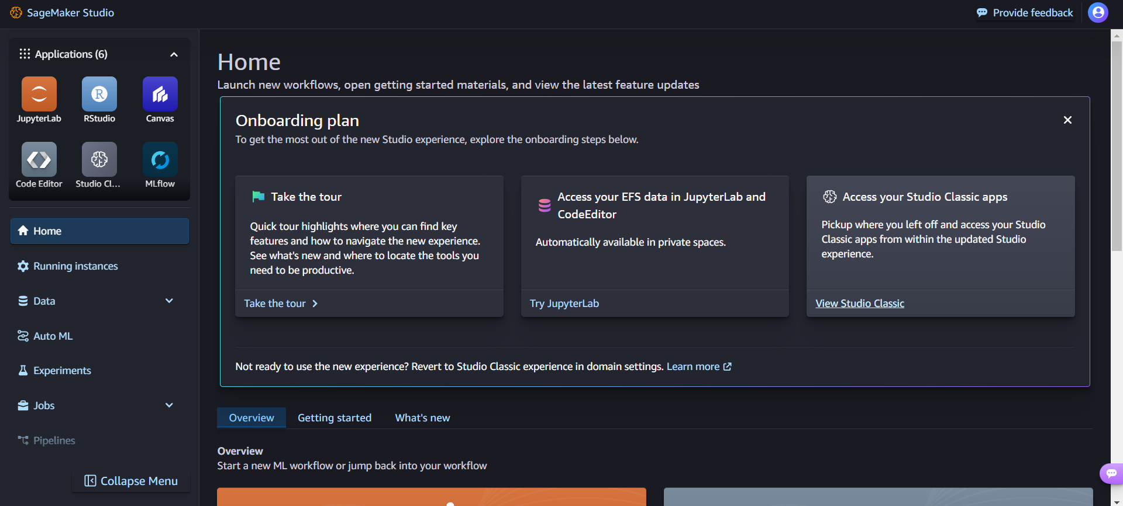

**6. In Studio, select Jupyter Lab and upload the .ipynb file.**

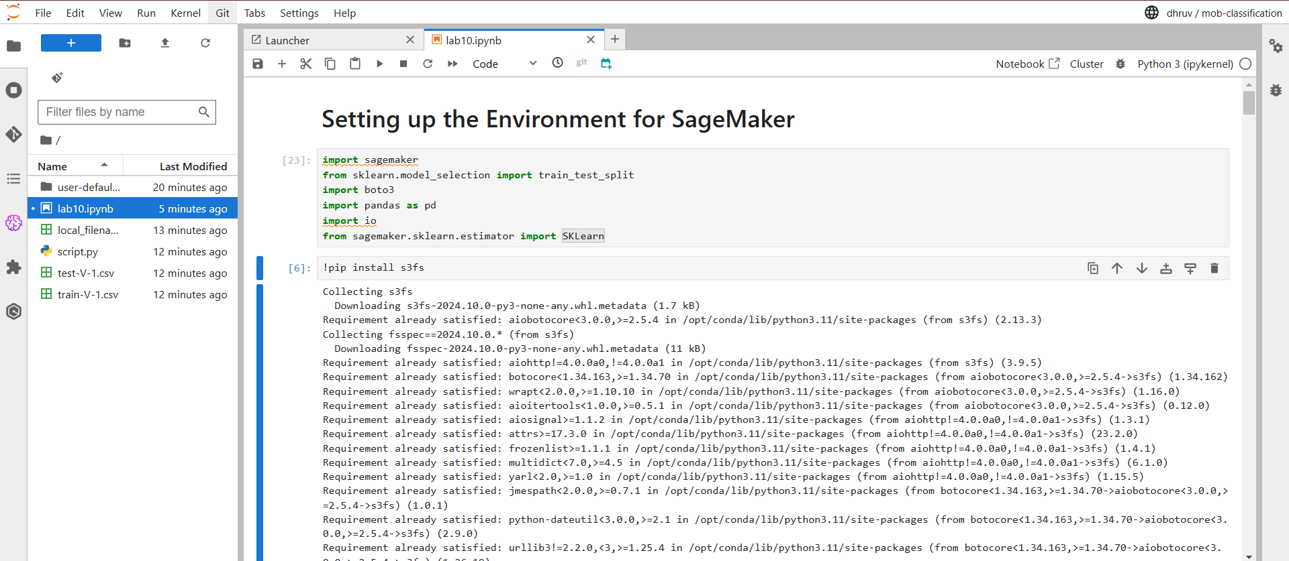

**7. Update the bucket name, ARN role or any other dependencies and run it.**

**Final Output:**

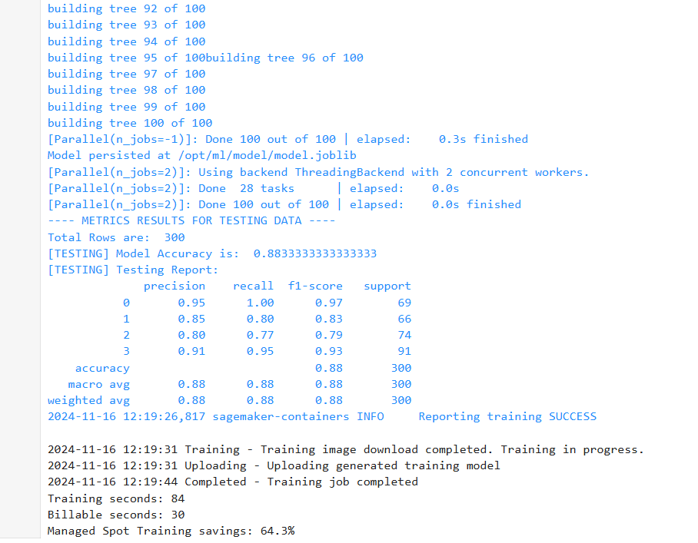

**Successfully trained and attained accuracy of 88%.**

**Conclusion: Successfully able to utilize Amazon SageMaker to run and train machine learning model and S3 for storage.**